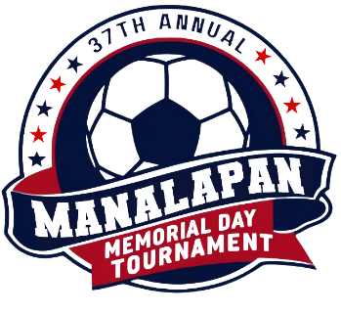

**MANALAPAN SOCCER CLUB**

**2025 MEMORIAL DAY TOURNAMENT**

**GUIDELINES/POLICIES/RULES ACKNOWLEDGEMENT**

**PLAYER CARDS:** I have in my possession original player cards/passes for all players. All player passes, rostered or guest, are from the same governing body. I will have all players, roster and cards available at the field at least 15 minutes prior to game time.

**TOURNAMENT ROSTERS:** I will only use eligible players submitted and approved at the time of online team check-in as detailed in my Tournament Roster and Official State Roster (with guest player names and pass #s handwritten) or approved by a Tournament co-director subsequently. I understand that players can only be rostered on one team for the Tournament. In the event of any discrepancy with respect to player passes and tournament rosters at games, the electronically submitted and verified Official State Roster (with hand written guest players) will be utilized to make final determinations of player eligibility. Use of ineligible players in any game will result in automatic forfeiture of the game and potentially the Tournament at the discretion of the Tournament director(s).

**MEDICAL RELEASE FORMS:** I certify that I am in possession of Medical Release forms for all players playing on my team in this tournament. I release Manalapan Soccer Club, the facility, vendors and all participating sponsors, from all responsibility regarding injuries.

**TOURNAMENT RULES:** I have read a copy of the tournament rules and will abide by them.

**ABUSIVE BEHAVIOR:** Any coach, trainer, parent, team official, player or spectator threatening violence to any individual will immediately be dismissed from the tournament. Verbal abuse from any coach, trainer, parent, team official, player or spectator will not be tolerated. Appropriate action will be taken by the Tournament Director or his/her designee, and could result in the team’s dismissal from the tournament.

**HOTELS:** Teams who are disrespectful and/or damage hotel property will be dismissed from the tournament and will not be accepted for future participation. Additionally, the team(s) will be responsible for all expenses.

**SCHEDULE/TOURNAMENT COMMUNICATIONS:** I will check gotsoccer.com or www.manalapansoccerclub.com for all game schedules (time and field) including the time/field of all placement games after the first three games are completed for all teams in my flight, if applicable. I will relay all applicable tournament messages from the tournament directors and all game schedules as posted on gotsoccer.com or manalapansoccerclub.com.

**I accept and will abide by the above rules/guidelines/liability on behalf of my team.**

**TEAM NAME:** **AGE U****Girls**  **Boys**

**PRINT NAME****PHONE NUMBER**

**SIGN NAME** **DATE**

(Printing your name is acceptable as a signature)